**# 📘 Project Documentation: Personal Portfolio Website**

**## 1. Overview**

This is a **\*\*personal portfolio website\*\*** designed and developed by and for  **\*\*Patrick Kariuki\*\***, a **\*\*Data Analyst and Web Developer\*\***.

The portfolio serves as a digital resume, showcasing professional skills, certifications, projects, and achievements in a visually appealing and responsive manner.

The project is built using **\*\*HTML, CSS, and JavaScript\*\***, and deployed using **\*\*GitHub Pages\*\*** for free hosting.

---

**## 2. Objectives**

- ✅ Create an **\*\*online presence\*\*** for professional branding.

- ✅ Provide a **\*\*central hub\*\*** to showcase projects, skills, and certifications.

- ✅ Ensure the site is **\*\*responsive\*\***, accessible across desktop, tablet, and mobile devices.

- ✅ Implement **\*\*modern design principles\*\*** with animations and transitions.

- ✅ Enable potential employers, clients, and collaborators to **\*\*connect easily\*\*** via a contact form.

---

**## 3. Features**

- **\*\*Home Page\*\*** – Hero section with animated background, introduction, and highlights.

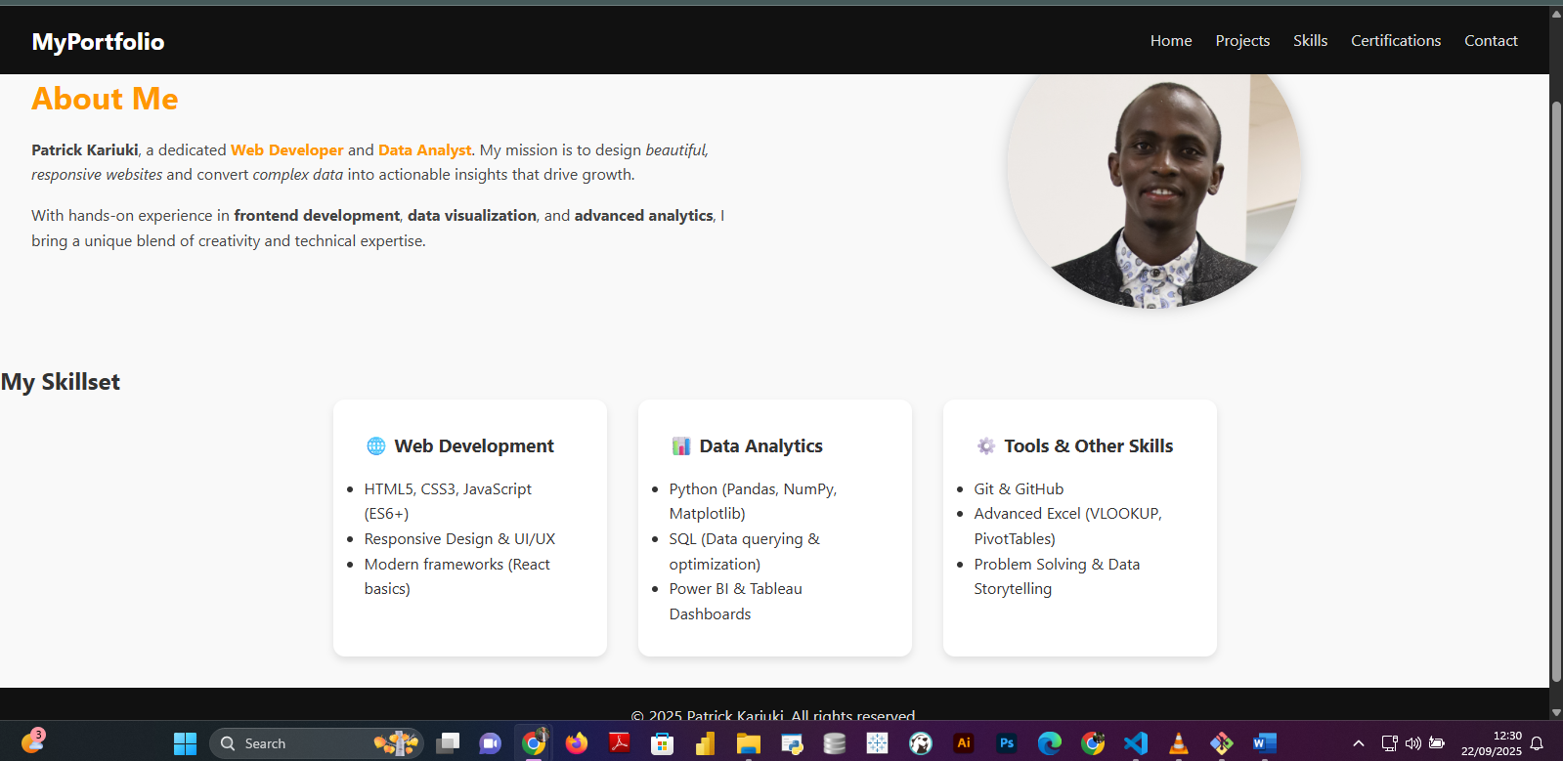

- **\*\*About Page\*\*** – Personal story, career journey, and professional summary.



- **\*\*Projects Page\*\*** – Portfolio of completed and ongoing projects with descriptions.

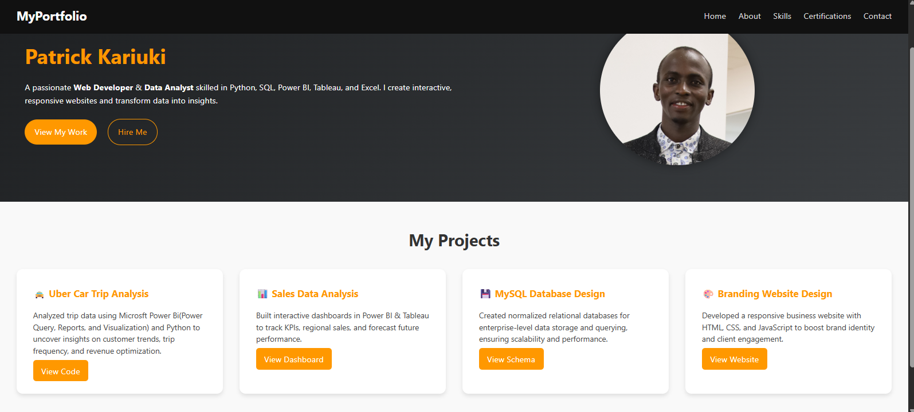

- **\*\*Skills Page\*\*** – Technical and analytical skills presented in **\*\*card-based design\*\***.

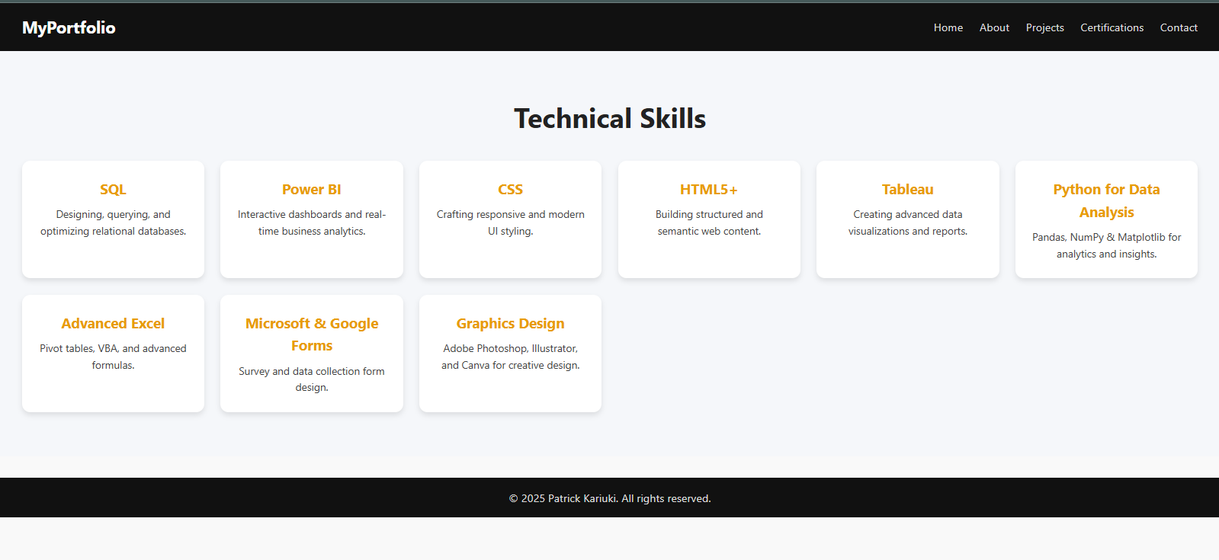

- **\*\*Certifications Page\*\*** – Display of completed certifications such as:

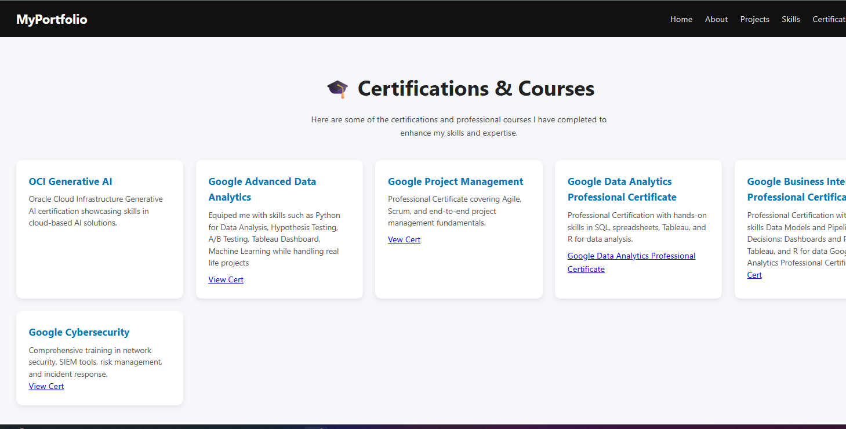

  - OCI Gen AI

  - Google Data Analytics Professional Certificate

  - Google Cybersecurity Professional Certificate

  - Google Business Intelligence Professional Certificate

  - Google Project Management Certificate

  - Cisco CyberOps

- **\*\*Contact Page\*\*** – Contact form with input validation (JS) for collecting inquiries.

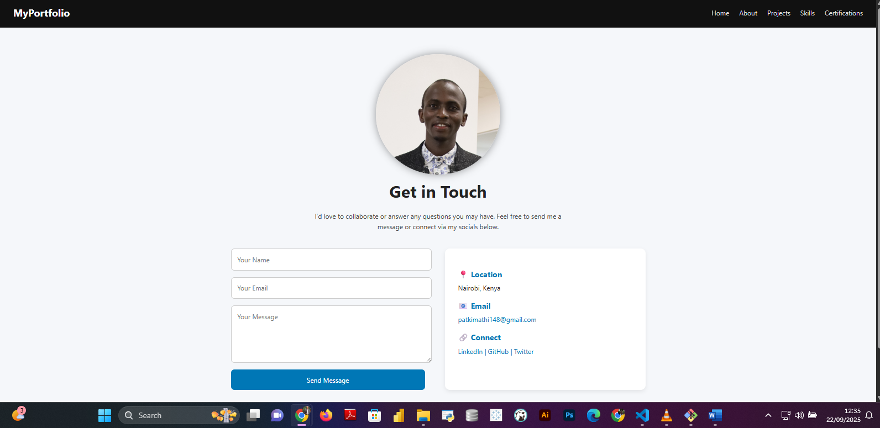

- **\*\*Responsive Navigation Bar\*\*** – Dropdown menu for small screens with hamburger toggle.

- **\*\*Animations & Transitions\*\*** – Motion background, smooth hover effects, and fade-in sections.

---

**## 4. Technologies Used**

**### Frontend**

- **\*\*HTML5\*\*** – Structure and semantic markup.

- **\*\*CSS3\*\*** – Styling, animations, responsive layout (media queries, flexbox, grid).

- **\*\*JavaScript (ES6+)\*\*** – DOM manipulation, form validation, navbar toggle, animations.

**### Tools & Platforms**

- **\*\*Git & GitHub\*\*** – Version control and repository hosting.

- **\*\*GitHub Pages\*\*** – Free deployment platform.

- **\*\*VS Code\*\*** – Code editor for development.

---

**## 5. Project Structure**

```bash

portfolio-website/

│

├── index.html            # Home Page

├── about.html            # About Me

├── projects.html         # Projects

├── skills.html           # Skills

├── certifications.html   # Certifications & Courses

├── contact.html          # Contact Page

│

├── css/

│   └── style.css         # Stylesheet

│

├── js/

│   └── script.js         # JavaScript functionality

│

├── images/               # Profile and project images

│

├── README.md             # Project summary

└── DOCUMENTATION.md      # Detailed project documentation (this file)

```

---

**## 6. Installation & Setup**

**### Option 1 – Run Locally**

1. Clone the repository:

   ```bash

   git clone https://github.com/your-username/portfolio.git

   cd portfolio

   ```

2. Open `index.html` in your browser.

**### Option 2 – Live Deployment**

The website is hosted on **\*\*GitHub Pages\*\***:

```

https://your-username.github.io/portfolio/

```

---

**## 7. How to Contribute**

This is a personal portfolio project, but contributions can include:

- Bug fixes in code.

- Suggestions for better design or performance improvements.

- Adding dark/light theme toggle.

Fork the repo, create a feature branch, and submit a pull request.

---

**## 8. Future Enhancements**

- 🌙 **\*\*Dark/Light mode toggle\*\*** for accessibility.

- 📩 **\*\*Backend integration\*\*** for the contact form (Node.js, Firebase, or Formspree).

- 🌐 **\*\*Multilingual support\*\*** (English + Swahili).

- 📊 **\*\*Blog Section\*\*** to share insights on Data Analytics and AI.

- 🔐 **\*\*Enhanced Security\*\*** with input sanitization and reCAPTCHA for the contact form.

---

**## 9. License**

This project is licensed under the **\*\*MIT License\*\*** – free to use, modify, and distribute with attribution.

---

**## 10. Author**

👤 **\*\*Patrick Kariuki\*\***

- 💼 Data Analyst | Web Developer  |UI UX Designer

- 📧 Email: patkimathi148@gmail.com

- 🌍 Portfolio: https://patrickkimathi.github.io/patrickkimathi.github.io-my-portfolio

- 🔗 LinkedIn: https://www.linkedin.com/in/patrick-kariuki-5914b7186/